## **BMR Pricing Model Project Report**

**PROBLEM IDENTIFICATION & PROJECT GOAL**

BMR has been charging a premium above the average market price without the support of a price model. With a recent investment of $1.54M in an additional chair lift, BMR needs to make changes to either cut costs without undermining the ticket price or support an even higher ticket price. The goal of this project is to deliver a valid price model to help set the optimal ticket price based upon BMR’s facilities and use the model to direct future facility operation and investment strategies.

**FINDINGS**

BMR currently charges $81 for a ticket. Our price model suggests that an average price of 95.87 is supported by featured facilities BMR offers in the relevant market segment. While this may sound surprising, since BMR’s already charging a premium above the average market price in Montana, the potential increase of BMR’s ticket price can be supported by featured facilities BMR offers, which are mostly in the highest categories in those top features as illustrated in the below plots as illustrated in the below charts.

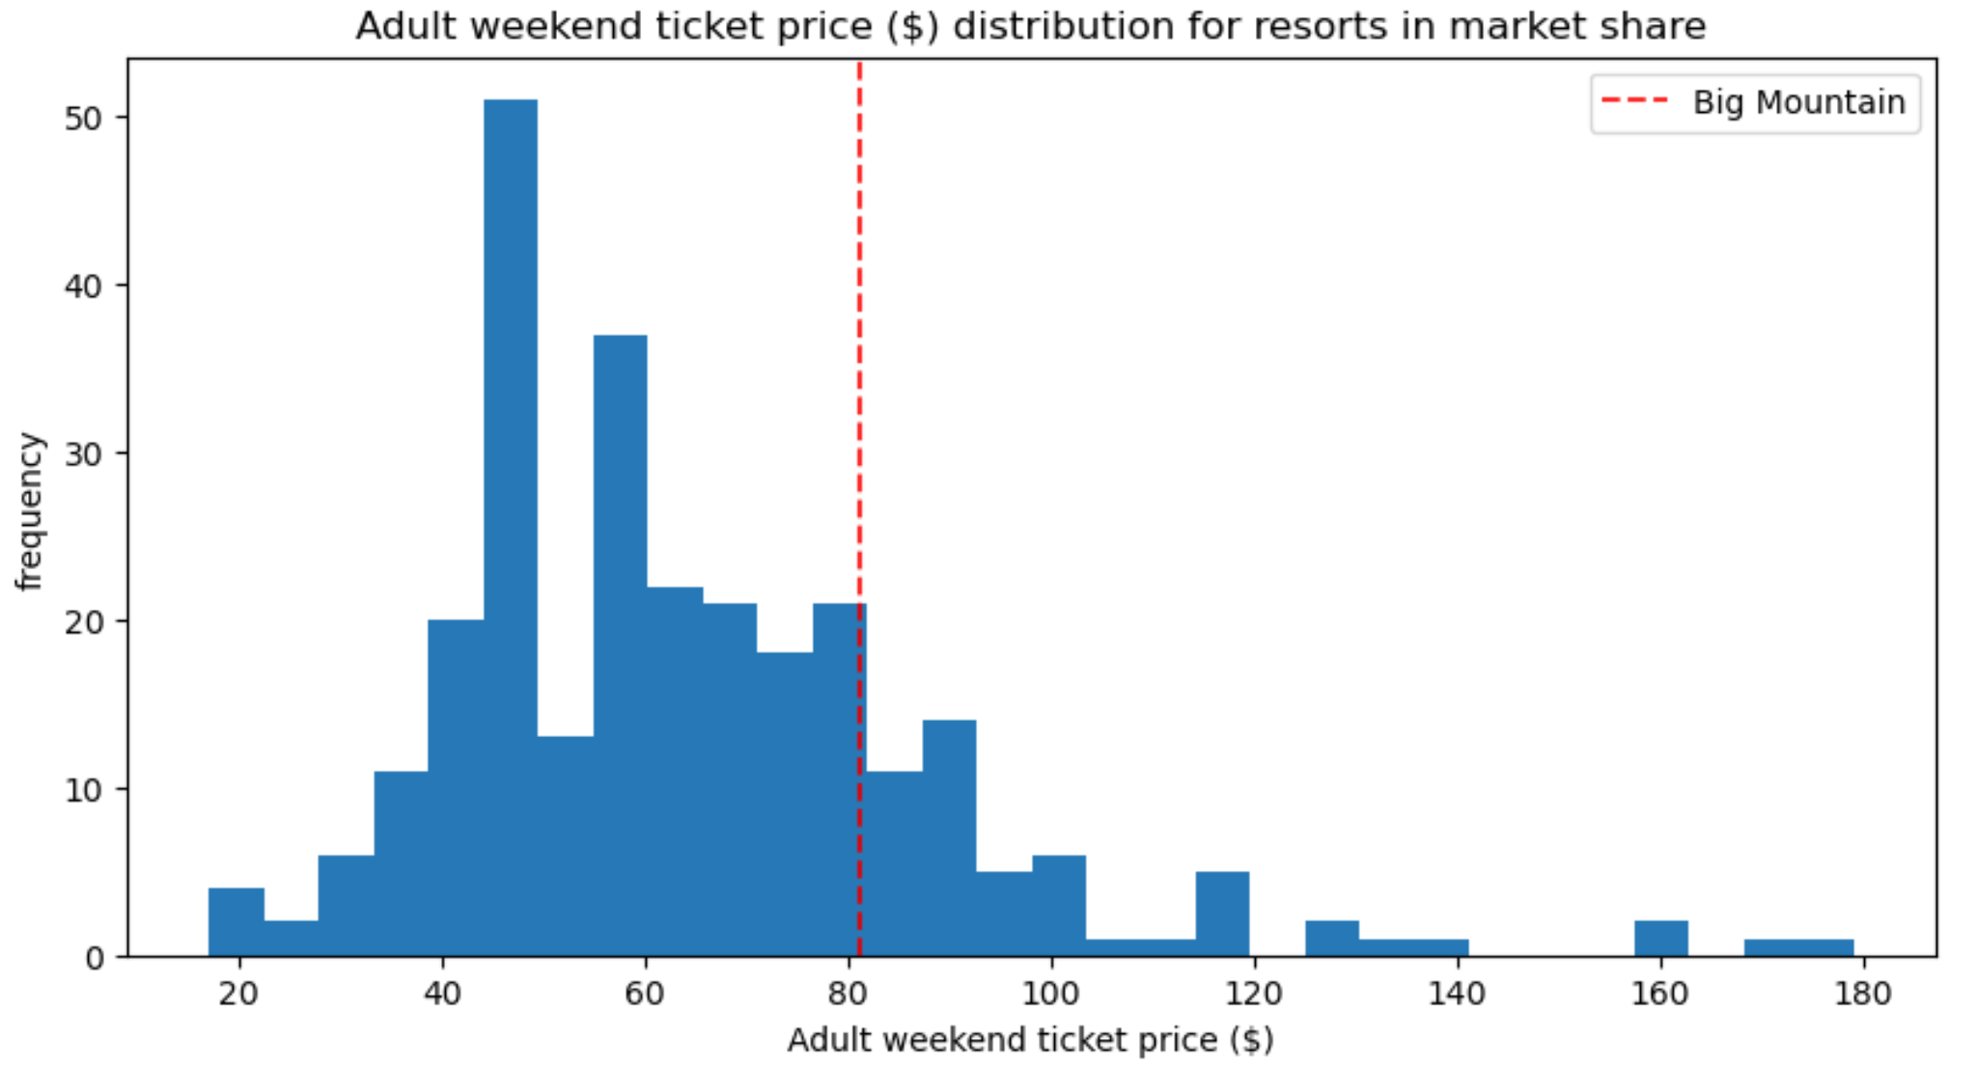 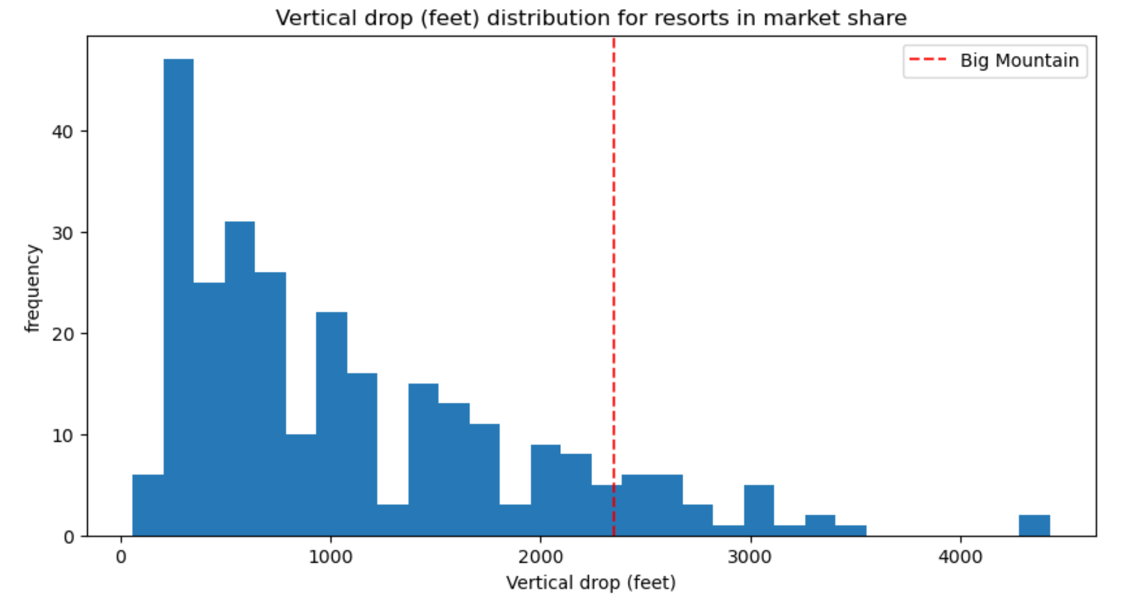

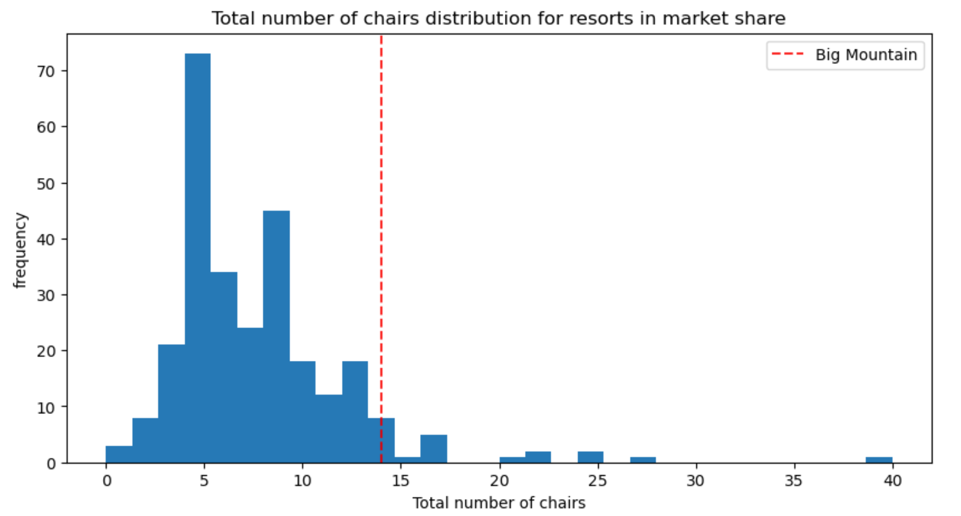 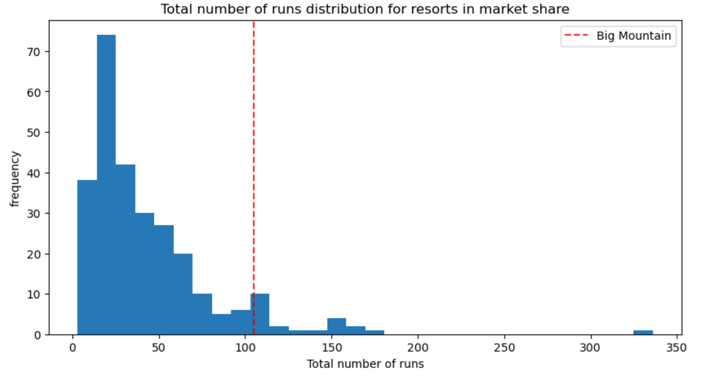

**RECOMMENDATIONS**

1. Permanently closing down the least used run. This doesn't impact the ticket price and hence the revenue as shown in the below charts, but will reduce the operation cost associated with keeping the run open. Closure of any addition runs beyond 1 will need further evaluation.

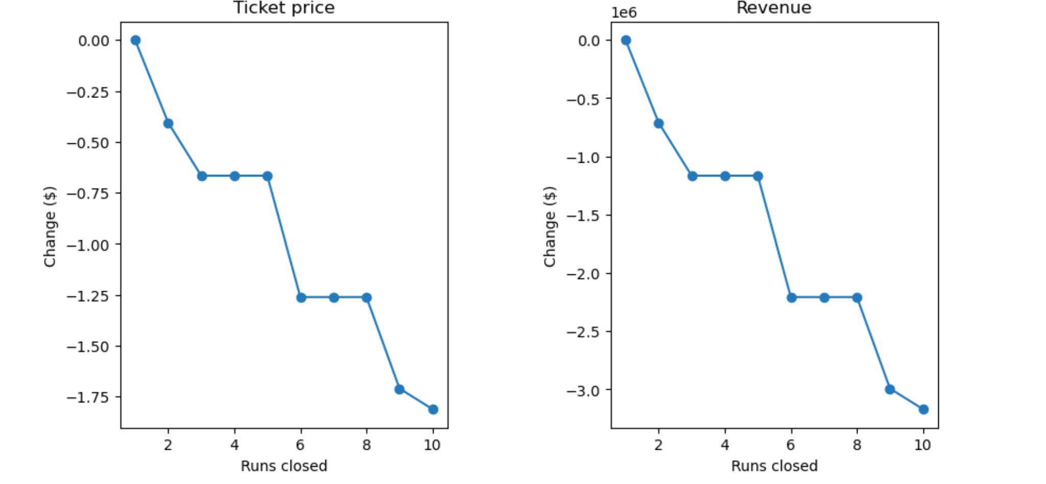

1. Increase the vertical drop by adding a run to a point 150 feet lower down and installing an additional chair lift to bring skiers back up, without additional snow making coverage. This will increase support for ticket price by $1.99, which converts to $3,474,638 additional revenue based upon the assumptions that all visitors buy 5 tickets and there are a total of 350,000 visitors over the season.
2. Start preparing the introduction and promotion of BMR’s ticket price increase based upon the price model to accurately reflect all BMR’s current facilities and any future facilities it plans to invest in. The focus of the promotion should be on the additional value BMR offers through its featured facilities, not the price increase itself.